**Course Project - Point of Sale Case Study**

Shaun Pritchard

Rasmussen College

QMB4900

James Grooms

January 22, 2021

**Course Project - Point of Sale Case Study**

Supper Shoppers Store sales analysis report will seek to answer several business questions in relation to individual and combined data analysis per the 10- Supper Shopper store locations. I had to re-modify my dataset by formatting headers and cleaning my data*(dataset-attached).* I then added new calculations and metrics to be used after adding the 2 datasets of store data and warehouse data together using python to create a data frame and output extra columns to use create data for several new key metrics relative to business questions that need answered. I then created several new tables to derive business intelligence as outlined below.

**Insights used will be to identify:**

* Keeping the shelves stocked and best-selling products on hand
* Identifying Inventory Management flaws
* Reducing cost and overhead with overstocked inventory
* Inventory Patterns

This analysis and visualizations report is broken down into categories based off the individual store per location and combined data used to answer specific business questions to provide insights. This report will initially start with the final analysis and recommendations facilitating the insights as noted characterized above in Analysis Report Index.

**Analysis Report Index:**

1. **Business Questions**
2. **Final Analysis (Business Intelligence)**
3. **Recommendations**
4. **Super Shopper Store Analysis (Store 1 Through 10)**

**Business Questions:**

In order to establish sound metrics understanding the dataset, revealing specific metrics that will allocate answering or profound questions that are essential to understanding the issues Super Shoppers is currently facing. The questions posed below need to be answered with data. I have outlined the questions and description of each question in reference to how it will provide business intelligence.

* Which products are running out of stock first per store
* How frequently are stores running out products
* Which products are not selling
* Does the amount of stock inventory needed to facilitate Reorder Point facilitate the demand of inventory per store
* What are the average products needed per store
* What is the profit loss based on the current inventory threshold
* What is the average Inventory value
* Regression Analysis of Profit and Loss of sales

To best answer these questions I have implemented a data workflow to facilitate new metrics based on calculations to provide information on Inventory Turnover, (RIO) Return On Investment, Sell-Through-Rate, Sales Velocity, Margins Per Product Unit, Sale Price With Margin Cost, Average Sales, Per Week, Per Store, Per Product, Average Inventory Values, Individual Store Profit & Loss Regressions.

**Description of Metrics:**

* Return on investment (ROI) is a ratio used to determine a business’s profitability. It is calculated by taking your net profit and dividing it by the cost of the investment.
* Implement X and Y Values to develop simple linear regression using Store Profit and Loss summations.

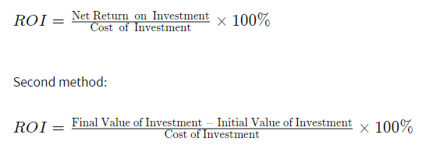

* Inventory “turnover” is a measure of how often a business sells through its entire inventory in a set period of time (often a year). In our case 8 weeks; I then calculated it by dividing the total sales by the average inventory value or cost of goods sold. these calculations also had to be discovered with new metrics inside the data.
* Sell-through rate is a calculation that is used to measure the amount of product received from Super Shoppers manufacturer against the amount of product sold to your customers in a specified period of time. To calculate it, using the total sales and divide that number by the stock on hand. Multiply this number by 100 to convert it to a percentage.
* Sales velocity is a way to measure how fast Super Shoppers products sell when they are available to thier customers. By multiplying the number of potential customers in a given period of time by the average selling price of a product and customer conversion rate, then divide that number by the average length of time it takes for a customer to convert. To calculate the Customer conversion rate. I took an averaged total of the number of products sold per week. These products sold where in fact customers; the conversion rate is the number of conversions divided by the total number of visitors.

**Final Analysis (Business Intelligence)**

Based on the given data from each store I was able to extract and analyze specific business information and trends as follows. This is an over all look at the stores combine. All the individual store data is listed below in the respected section analyzed for each store.

**Top Selling Products:**

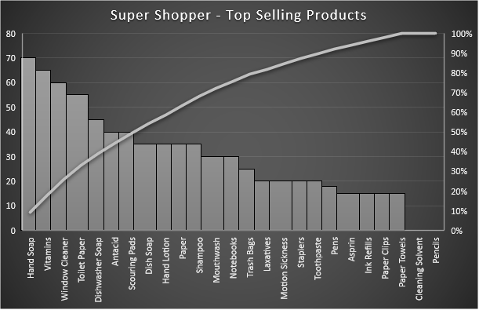

The distribution above shows the calculations of inventory sold for each Super Shoppers Store. The data shows us that the following are the top selling items across all stores over 8 week period of time as per the dataset provides.

1. **Hand soap**
2. **Vitamins**
3. **Window Cleaner**

**Top 3 Products Most Out of Stock**

I had to use separate calculations and distribution to find out how many items in stock sold each week while retaining the original amount by counting the times stock ran out and = 0, then calculated the difference to find out exactly how much inventory was sold from the original full Stock column of data then cross referenced the data with distributions of warehouse inventory which corelated with the margins and reorder units values.

**Out of Stock Product Frequency**

The out of stock data shows combined analysis which shows the products which frequency is most out of stock. This analysis revels business intelligence about the inventory management used by Super Shoppers answering several business questions.

* We can see that reorders need to be more frequent,
* That warehouse inventory amounts need to be increased
* That the instore inventory amounts need to be increased
* Outliers & Errors
* Poor management due from bad inventory systems and communications from the warehouse and stores individually.

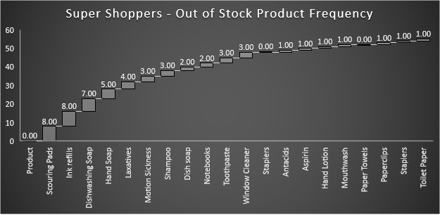

**Lest-Sold Products:**

These products across all stores had issues of overs Stocking. There are 2 main products where across each store stock was full products never sold. Products that never sell can be dead weight and cost Super shoppers in overhead, storage, and management.

Understanding which products are not producing margins for company can help Supers Shoppers optimize their inventory managements practices, overhead and overall operations. These metrics will show how products sitting on the shelf expiring could be cause to backlogged invintory and non-profitable items.

* **Pencils** – I would recommend discontinuing this product if trends over full year and normal distribution of appropriate time series (i.e. years, months…). This time series data was not available other than the 8-week intervals provided in the dataset.
* **Cleaning Solvent** - without time series data I cannot accurately recommend Discontinuing this product. Given the dataset, some products did sale. I would recommend implementing new Inventory management systems and raise the threshold for reorder point while lowering the storage amount in the warehouse to at least 50% of the current product inventory amounts.
* **Dish soap, Toothpaste, Aspirin, Antacids, and Paper** inventory products seem to be full but dd have a fair distribution of sale in other stores other than were the data points where acquired. I belive mismanagement and insufficient systems, practices, and processes are cause for overstock issues with these products and those related. Please see recommendations below

**Product Recommendations:**

Based off the analysis I used the distribution data to find the median average amount of products need per week across all stores to facilitate good product inventory amount and keep up with customer demand.



**Recommendations Analysis:**

To achieve these goals, I highly recommend implementing these strategies based off the data Provided above.

* Defining minimum ordering quantity for all listed products that will facilitate the average basis of sales forecasted in the Analysis
* Increase the reorder point for specific products that average a loss from being out of stock to soon.
* Drop Specific Products from inventory or keep minimum at hand with higher reorder point.
* Rising cost of best-selling products to increase the margin while lowering the reorder point to implement product replenishment.
* Allocate more fully stocked products on-hand for best sellers per store.
* Daily inventory assessment and analyzing processes.
* Using systematic inventory management techniques such as or to manage.
* Training staff to use the technology and inventory management tools. Such as (SAM) Software Asset Management Software *(Gartner Peer Insights, 2020).*
* Training staff to use the technology and inventory management techniques. Such as lean process, scheduled meetings, establishing KPI’s Categorize Your Inventory Using ABC Analysis hierarchy, Implement Reorder Point Formulas, Just-in-time system, or Kanban system *(DEAR Systems, 2017), (Systems, 2017).*
* Arranging Individual stores based of customer preference. Keep bestselling products in the front of the store, Stack inventory higher making better use of vertical spaces and end-caps *(Fdm4, 2020)*.
* Implementing lean principles while Maintaining the 5'S' in stores; Sort, Set in order, Shine, Standardize, and Sustain *(5S Today, 2020).*

**Super Shoppers 10 Store Individual Analysis:**

The below store analysis are detailed tree maps and descriptive statistics that reveal outliers and show trends in the current data per store. Each store has business questions answered individually. While being summarized in the above final analyses

**Store 1 Analysis:**

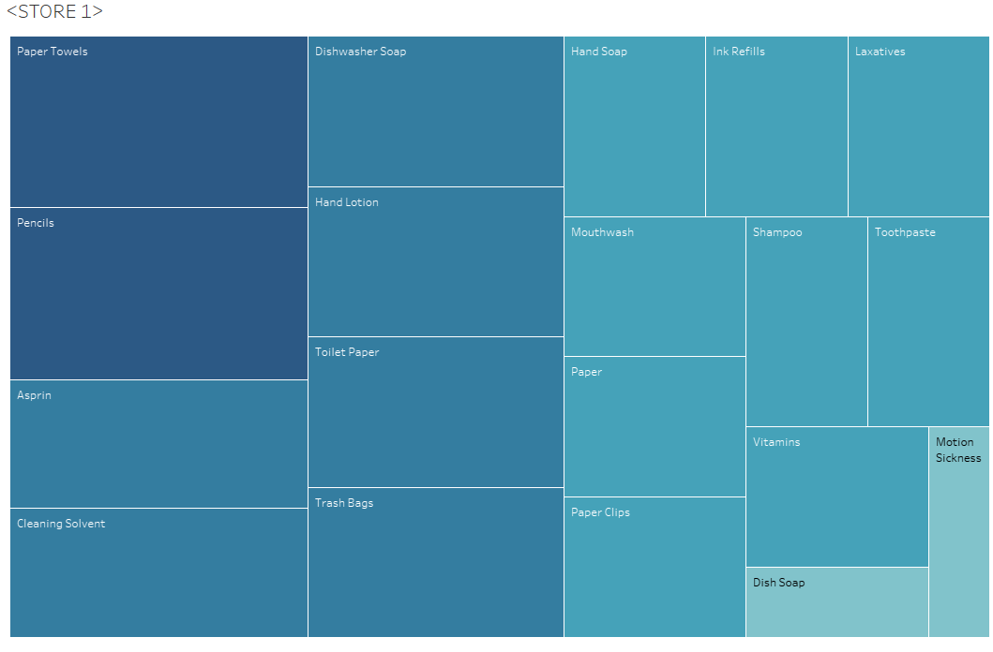

**Store 1 Data Analysis:**

**Errors:**

In week 6 in **Store 1** an error occurred for the inventory product Aspirin. Inventory showed fully stocked amount to be 20 compared to the inventory value 120 in week 6. Because the data shows week 5 inventory was down to 5 units I belive 15 units where ordered for the following week and this is just a data entry error.

**Highest selling products:**

Over the past 7 weeks to present these top products sold out the most and where not in stock

|  |  |  |  |  |
| --- | --- | --- | --- | --- |
| **Product** | **Stock Amount** | **#Weeks Sold out** | **Product Avg (Needed Per Week)** | **Analysis** |
| Staplers | 10 | 5 | 6.7 | Increase Stock Amount and reorder point |
| Motion Sickness | 10 | 3 | 5.0 | Increase Stock Amount and reorder point |
| Ink refills | 10 | 4 | 5.0 | Increase Stock Amount and reorder point |
| Dishwasher Soap | 15 | 4 | 9.1 | Increase Stock Amount and reorder point |
| Hand Soap | 20 | 4 | 13.9 | Increase Stock Amount and reorder point |
| Notebooks | 15 | 3 | 8.9 | Increase Stock Amount and reorder point |

I recommend increasing the stock amount to double all products by 50% or the calculated product average above. to meet the demand.

Also, follow recommendations and best practices I have outlined in the recommendations section of the analysis above. I belive the warehouse needs to adjust its reorder points for these products per this store schedule. The store should implement product placement and staging strategies to facilitate increasing profit margin through demand and visibility. I would also recommend instore management check to see if sound inventory management and tracking processes are being conducted correctly.

**Product Average** = Average of All sales divided by each week minus the full stock amount times 100 percent.

**Lowest selling products:**

|  |  |  |  |  |
| --- | --- | --- | --- | --- |
| **Product** | **Stock Amt** | **Sold (8weeks)** | **Product Avg (Needed Per Week)** | **Analysis** |
| Pencils | 20 | 0 | 0% | Remove product from store or reduce stock Amount to 5 and resell point by 75% |
| Cleaning Solvent | 15 | 3 | 0% | Reduce Stock Amount to 10 and reorder point by 50% |

**Product Profit and Loss**

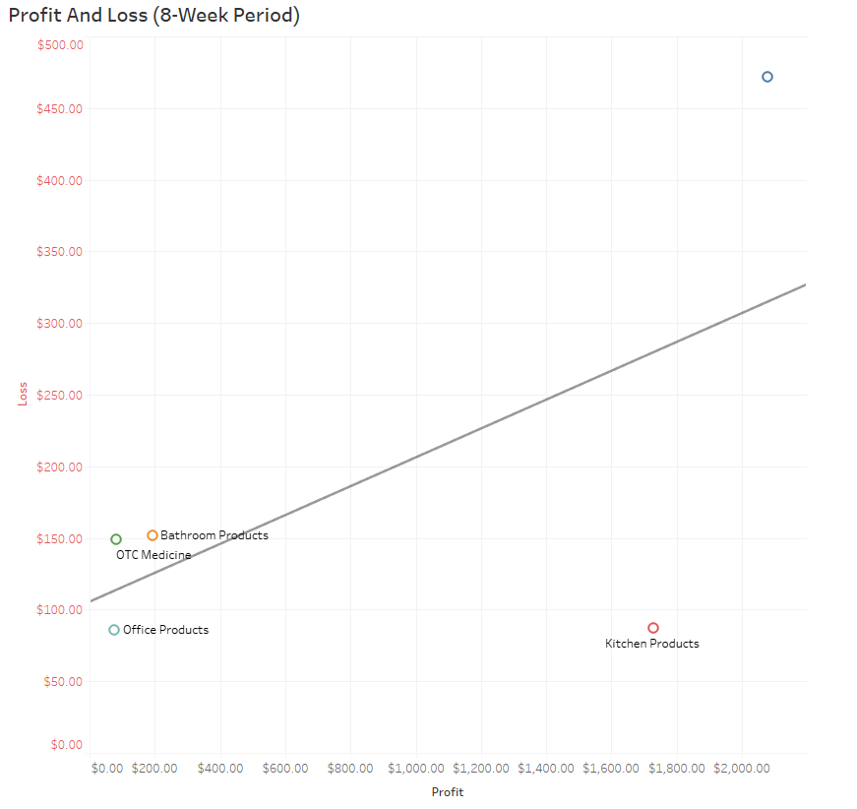

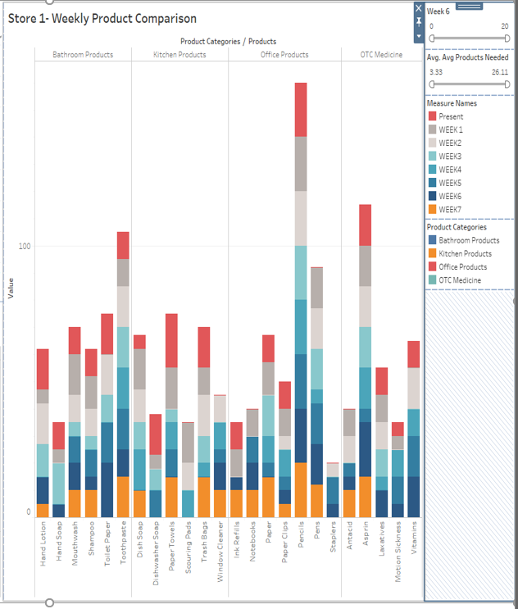

**Average Products Sold per Week**

Here are the store averages based in percentages of sales per week(8-weeks)

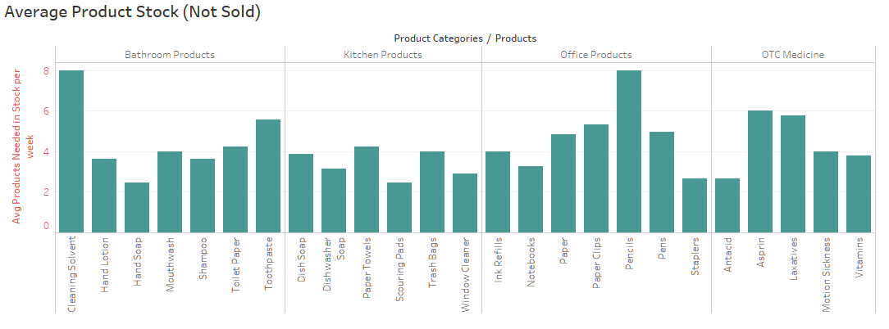

**Inventory Turn Over:**

 This is the measure of how often Super Shoppers Store 1 sells through its entire inventory in a set period of 8 weeks. By dividing the total sales by the average inventory value

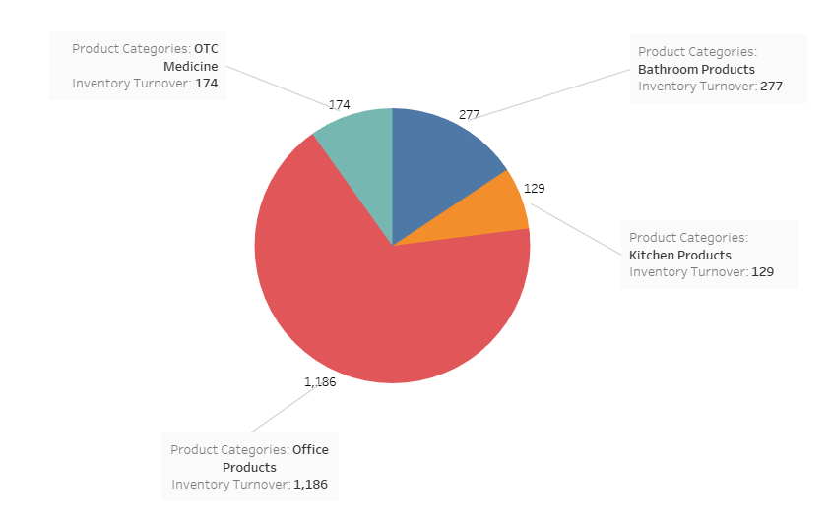

**Sell Through Rate:**

Sell-through rate is a calculation that is used to measure the amount of product received from your manufacturer against the amount of product sold to your customers in a specified period of time.

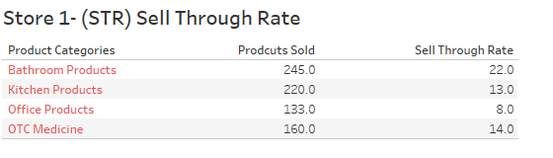

**Store 2 Analysis:**

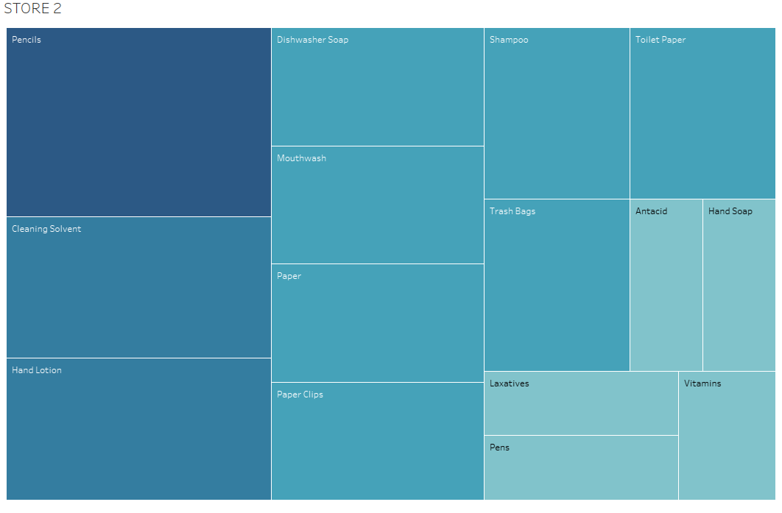

**Store 2 Data Analysis:**

**Errors:**

* In week 6 in **Store 2** an error occurred, or wrong reorder amount of hand soap was logged at 50 units. This could be a hum error or possible software issue. Full stock Amount should be 20.
* Week 17 products where completely out of stock. Re-order warehouse amount only sent 10 to 15 units when fully stocked inventory at this location needs to be 20 units. There is not enough product being sent to stock this store.

**Store 2 Highest selling products:**

Over the past 7 weeks to present these top products sold out the most and where not in stock

|  |  |  |  |  |
| --- | --- | --- | --- | --- |
| **Product** | **Stock Amount** | **#Weeks Sold out** | **Product Avg (Needed Per Week)** | **Analysis** |
| Ink refills | 10 | 5 | 3 | Increase Stock Amount and reorder point |
| Motion Sickness | 10 | 2 | 5 | Increase Stock Amount and reorder point |
| Toilet Paper | 20 | 2 | 7 | Increase Stock Amount and reorder point |
| Hand Soap | 20 | 2 | 11 | Increase Stock Amount and reorder point |
| Toothpaste | 20 | 2 | 10 | Increase Stock Amount and reorder point |
| Paper Towels | 20 | 2 | 6 | Increase Stock Amount and reorder point |
| Window Cleaner | 20 | 3 | 3 | Increase Stock Amount and reorder point |

I recommend increasing the stock amount to meet the demand especially for Ink refills and Motion Sickness medicine. I recommend that the warehouse reorder point be dropped to a less amount to cover the demand of the listed products.

Also, follow recommendations and best practices I have outlined in the recommendations section of the analysis above. The store should implement product placement and staging strategies to facilitate increasing profit margin through demand and visibility. I would also recommend instore management check to see if sound inventory management and tracking processes are being conducted correctly.

**Product Average** = Average of All sales divided by each week minus the full stock amount times 100 percent.

**Store 2 Lowest selling products:**

|  |  |  |  |  |
| --- | --- | --- | --- | --- |
| **Product** | **Stock Amt** | **Sold (8weeks)** | **Product Avg (Needed Per Week)** | **Analysis** |
| Pencils | 20 | 0 | 20 | Remove product from store or reduce stock Amount to 5 or increase resell point by 75% |
| Dish Soap | 15 | 3 | 9.25 | Reduce Stock Amount to 10 and reorder point by 50% |

**Store 2 Product Profit and Loss:**

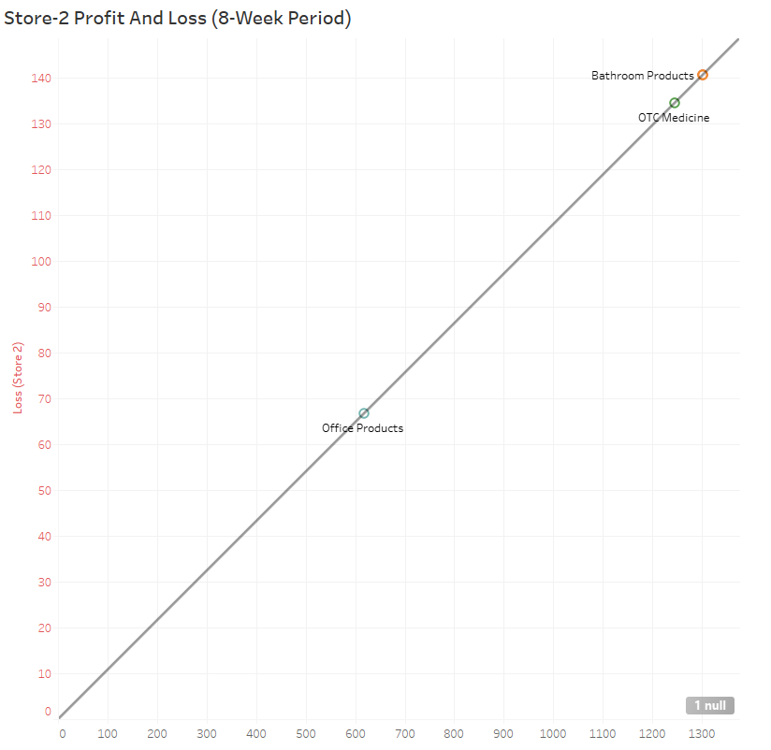

**Store 2 Average Products Sold per Week**

Here are the stores average percentages of sales per week

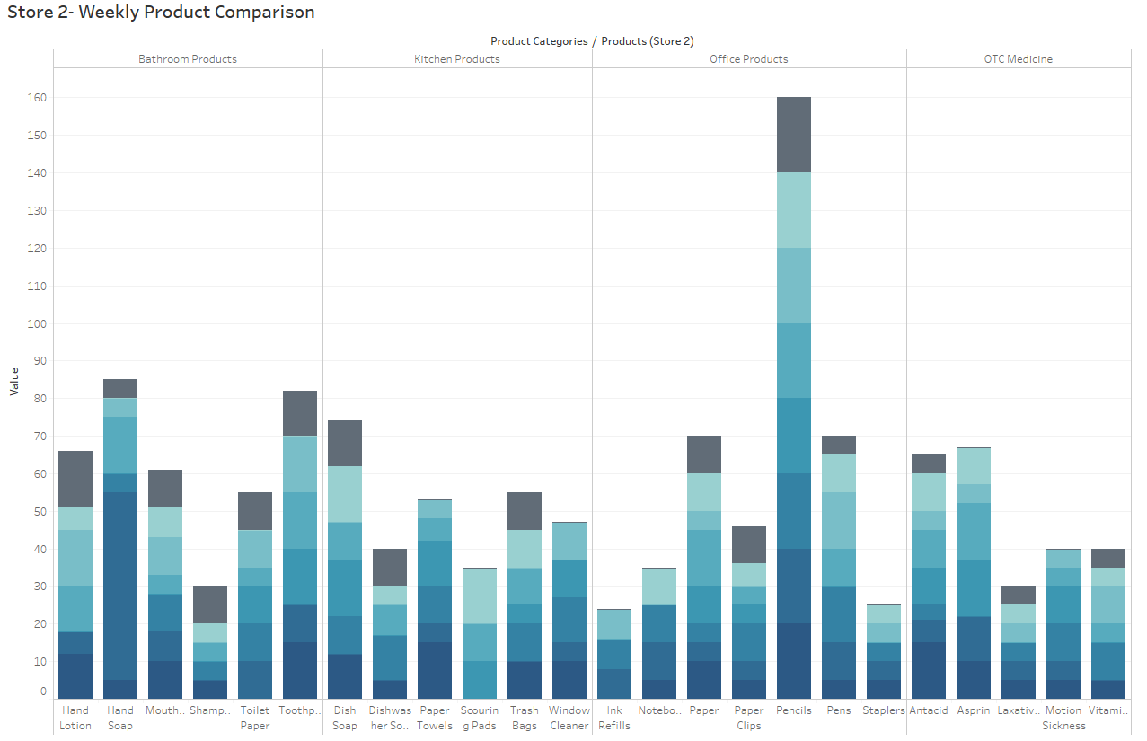

**Store 2 Inventory Turn Over:**

 This is the measure of how often Super Shoppers Store 1 sells through its entire inventory in a set period of 8 weeks. By dividing the total sales by the average inventory value

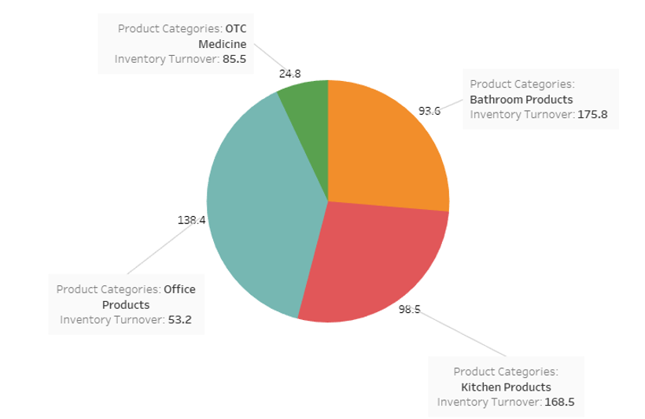

**Store 2 Sell Through Rate:**

Sell-through rate is a calculation that is used to measure the amount of product received from your manufacturer against the amount of product sold to your customers in a specified period of time.

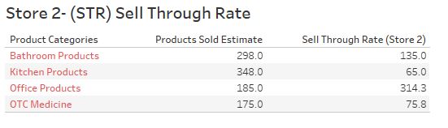

**Store 2** ROI:

Return on investment based on calculating the profit made divided by the initial cost of products purchased in inventory:

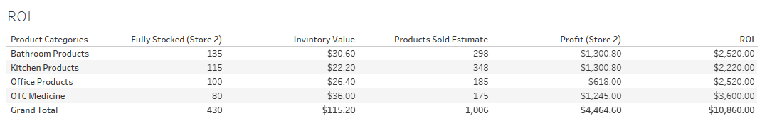

**Store 3 Analysis:**

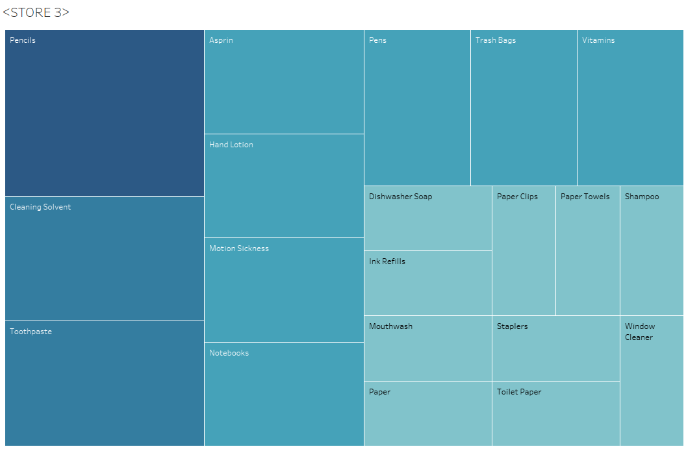

**Store 3 Data Analysis:**

**Errors:**

**Store 3** Did not seem to have many errors, products inventory amounts seemed to suffice the demand. Only on a few occasions mentioned below did products sell out and where out of stock for more that 1-4 weeks.

**Store 3 Highest selling products:**

Over the past 7 weeks to present these top products sold out the most and where not in stock

|  |  |  |  |  |
| --- | --- | --- | --- | --- |
| **Product** | **Stock Amount** | **#Weeks Sold out** | **Product Avg (Needed Per Week)** | **Analysis** |
| Dish soap | 20 | 3 | 5.25 | Increase Stock Amount and decrease reorder point |
| Toothpaste | 20 | 3 | 7.5 | Increase Stock Amount and decrease reorder point |
| Scouring Pads | 20 | 4 | 4.3 | Increase Stock Amount and decrease reorder point |

I recommend increasing the stock amount to meet the demand especially for Dish soap and Toothpaste, and Scouring Pads I recommend that the warehouse reorder point be dropped to a less amount to cover the demand of the listed products.

Also, follow recommendations and best practices I have outlined in the recommendations section of the analysis above.

**Product Average** = Average of All sales divided by each week minus the full stock amount times 100 percent.

**Store 3 Lowest selling products:**

|  |  |  |  |  |
| --- | --- | --- | --- | --- |
| **Product** | **Stock Amount** | **#Weeks Sold out** | **Product Avg (Needed Per Week)** | **Analysis** |
| Pencils | 20 | 0 | 20 | Decrease or cancel Stock Amount and reorder point |
| Cleaning Solvent | 15 | 0 | 15 | Decrease Stock Amount and reorder point |

**Store 3 Product Profit and Loss:**

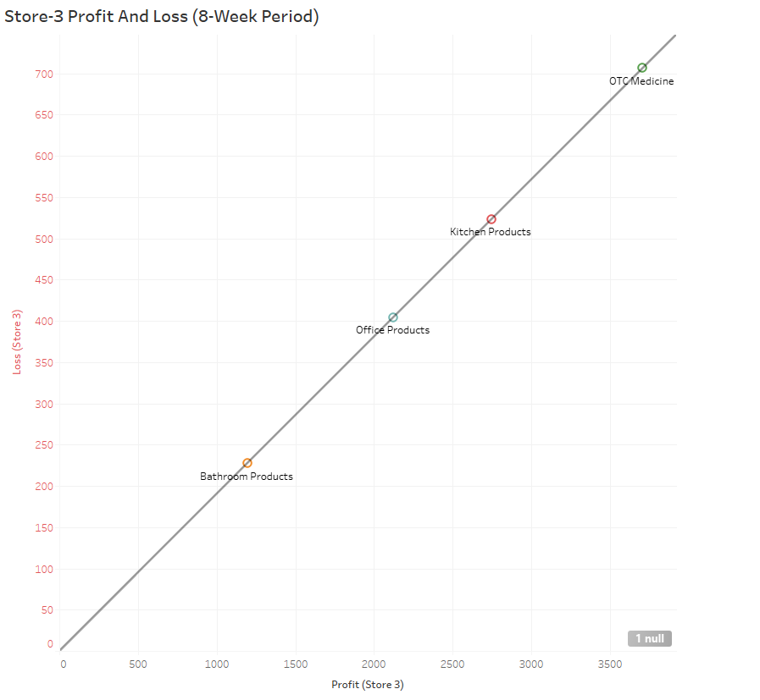

**Store 3 Average Products Sold per Week**

Here are the store averages based in percentages of sales per week(8-weeks)

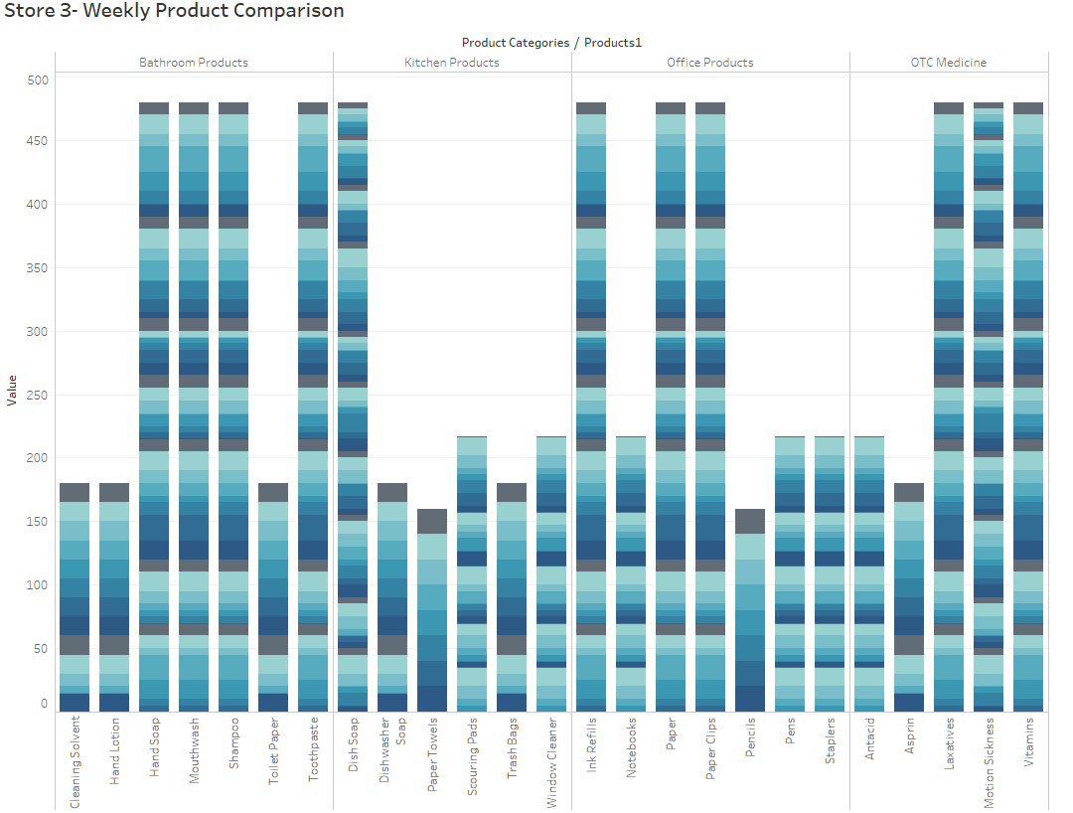

**Store 3 Inventory Turn Over:**

 This is the measure of how often Super Shoppers Store 1 sells through its entire inventory in a set period of 8 weeks. By dividing the total sales by the average inventory value

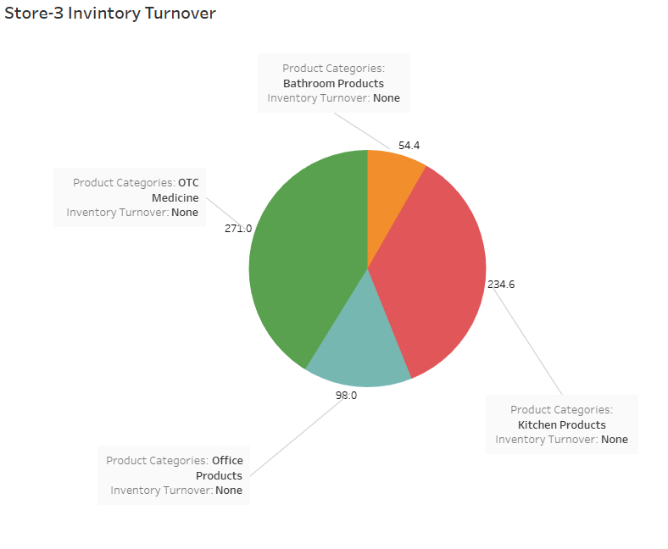

**Store 3 Sell Through Rate:**

Sell-through rate is a calculation that is used to measure the amount of product received from your manufacturer against the amount of product sold to your customers in a specified period of time.

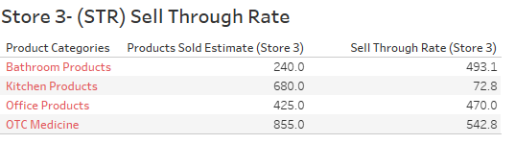

**Store 3 ROI:**

Return on investment based on calculating the profit made divided by the initial cost of products purchased in inventory:

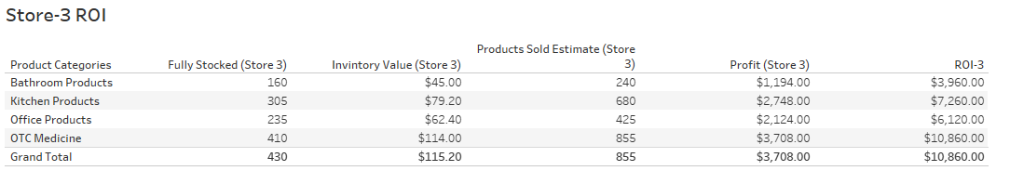

**Store 4 Analysis:**

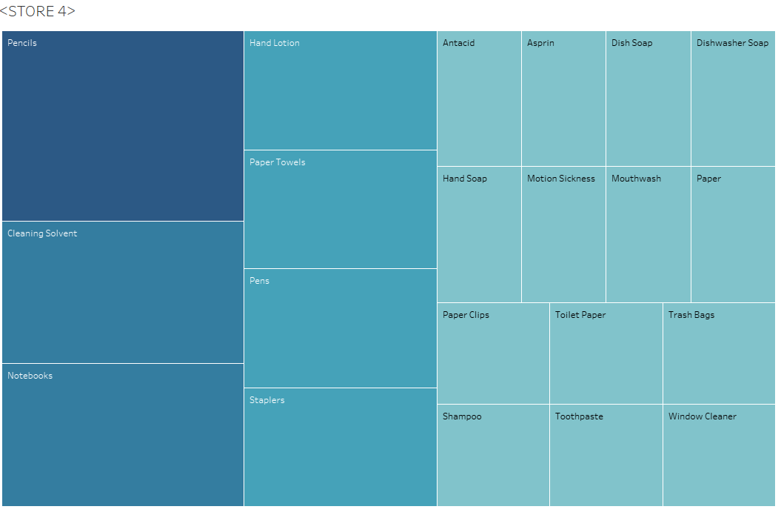

**Store 4 Data Analysis:**

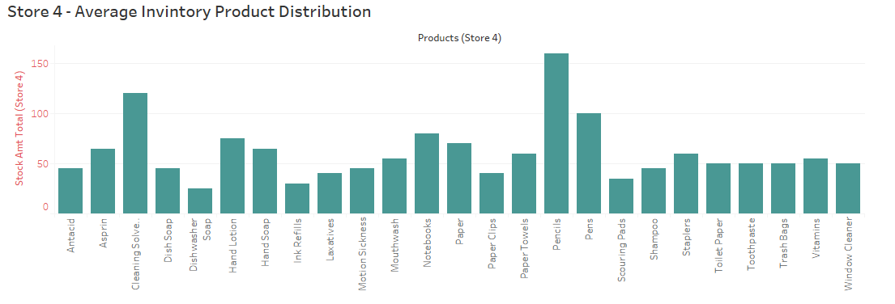

**Errors:**

* In week 6 We see that hand Office Products and Bathroom Products are completely out of stock, only receiving partial reorders of 5 products each the following week. This suggest the warehouse reorder point does not facilitate the demand for these 13 Products
* Again, as seen in store 1,2, and 3 I have noticed a trend with scouring pads being out of stock from week 5 to week 8(present). This suggest ether the warehouse needs to raise the stock amount and lower the reorder point. It could also suggest the internal inventory management process at each location is faulty and needs a new implementation using new systems.
* Again, as seen in store 1,2, and 3 I have noticed a trend with Pencils are not selling at all. This suggest the product is ineffective and non-profitable.
* Week 3 Window cleaner, trash bags, toothpaste, shampoo, toilet paper, notebooks, dishwasher soap, and ink refills are sold out. Only receiving minimum of 5 units the following completely sold out on week 5
* It appears that the reorder amounts(all Products) being distributed for each product by 5 units per week when on schedule.

**Store 4 Highest selling products:**

Over the past 7 weeks to present these top products sold out the most and where not in stock

|  |  |  |  |  |
| --- | --- | --- | --- | --- |
| **Product** | **Stock Amount** | **#Weeks Sold out** | **Product Avg (Needed Per Week)** | **Analysis** |
| Ink refills | 10 | 3 | 4 | Increase Stock Amount and reorder point |
| Dishwasher Soap | 15 | 3 | 3 | Increase Stock Amount and reorder point |
| Scouring Pads | 20 | 4 | 4 | Increase Stock Amount and reorder point |
| Shampoo | 20 | 3 | 6 | Increase Stock Amount and reorder point |
| Laxatives | 10 | 3 | 5 | Increase Stock Amount and reorder point |
| Hand Lotion | 20 | 3 | 9 | Increase Stock Amount and reorder point |

I recommend increasing the stock amount to meet the demand especially for Scouring Pads, Shampoo, and Hand Lotion. I recommend that the warehouse reorder point be dropped to a less amount to cover the demand of the listed products.

Also, follow recommendations and best practices I have outlined in the recommendations section of the analysis above.

**Product Average** = Average of All sales divided by each week minus the full stock amount times 100 percent.

**Store 4 Lowest selling products:**

|  |  |  |  |  |
| --- | --- | --- | --- | --- |
| **Product** | **Stock Amt** | **Sold (8weeks)** | **Product Avg (Needed Per Week)** | **Analysis** |
| Pencils | 20 | 0 | 20 | Remove product from store or reduce stock Amount to 5 or increase resell point by 75% |
| Cleaning Solvent | 15 | 0 | 15 | Reduce Stock Amount to 10 and reorder point by 50% |

**Store 4 Product Profit and Loss:**

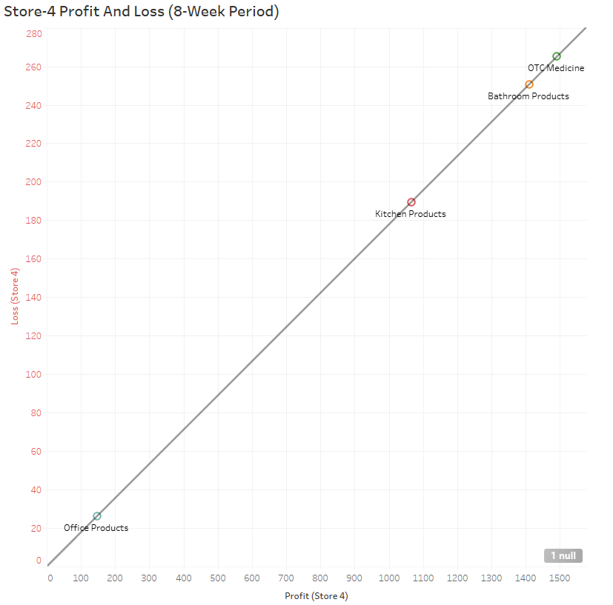

**Store 4 Average Products Sold per Week**

Here are the store averages based in percentages of sales per week(8-weeks)

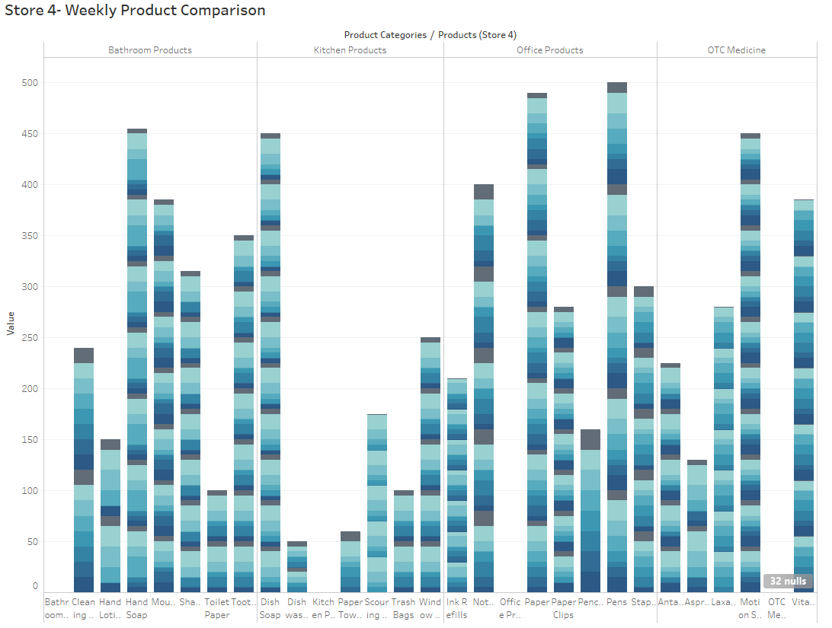

**Store 4 Inventory Turn Over:**

 This is the measure of how often Super Shoppers Store 1 sells through its entire inventory in a set period of 8 weeks. By dividing the total sales by the average inventory value

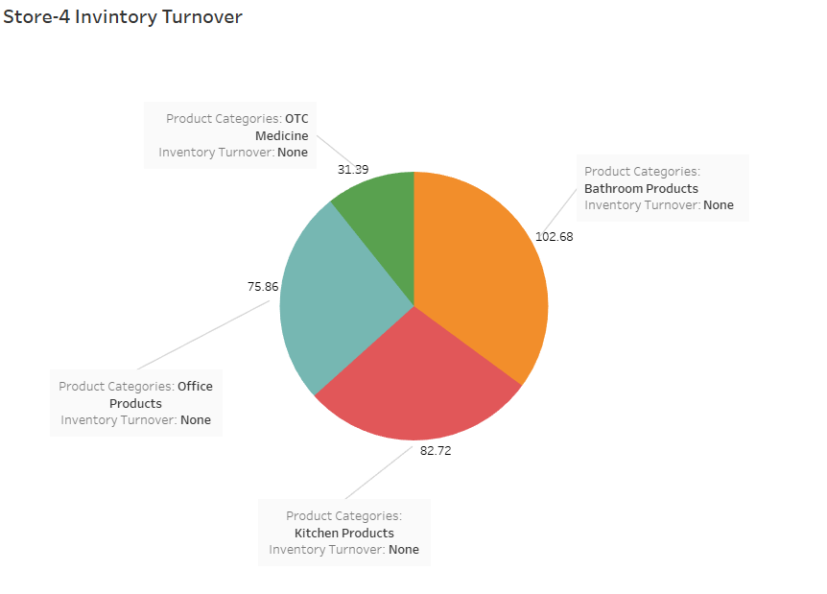

**Store 4 Sell Through Rate:**

Sell-through rate is a calculation that is used to measure the amount of product received from your manufacturer against the amount of product sold to your customers in a specified period of time.

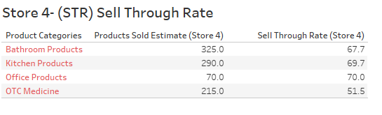

**Store 4 ROI:**

Return on investment based on calculating the profit made divided by the initial cost of products purchased in inventory:

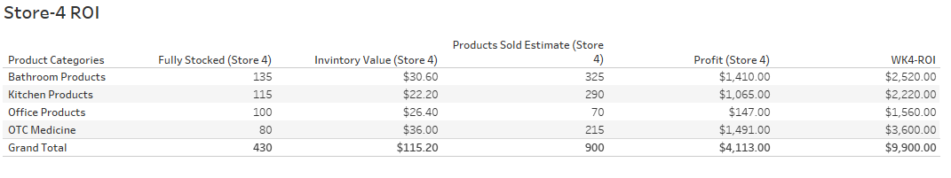

**Store 5 Analysis:**

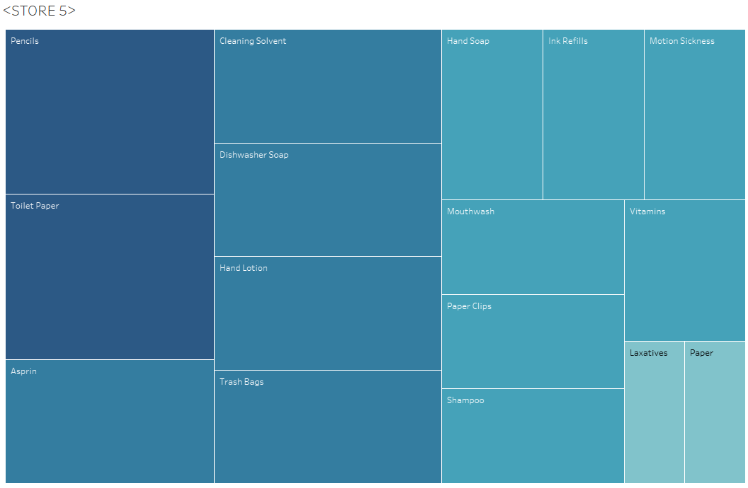

**Store 5 Data Analysis:**

**Errors:**

* In week 5 in **Store 5** Scouring Pads follow the trend going unordered for 4 weeks out of stock.

**Store 5 Highest selling products:**

Over the past 7 weeks to present these top products sold out the most and where not in stock

|  |  |  |  |  |
| --- | --- | --- | --- | --- |
| **Product** | **Stock Amount** | **#Weeks Sold out** | **Product Avg (Needed Per Week)** | **Analysis** |
| Scouring Pads | 20 | 5 | 4 |  |
| Ink refills | 10 | 4 | 4 | Increase Stock Amount and reorder point |
| Hand Soap | 20 | 4 | 4 | Increase Stock Amount and reorder point |
| Staplers | 10 | 4 | 5 | Increase Stock Amount and reorder point |
| Notebooks | 15 | 4 | 5 | Increase Stock Amount and reorder point |
| Dishwashing Soap | 15 | 4 | 5 | Increase Stock Amount and reorder point |
| Motion Sickness | 10 | 3 | 4 | Increase Stock Amount and reorder point |

I recommend increasing the stock amount to meet the demand especially for All products listed above that go more than 3 weeks without replenishing store 5 inventory. I recommend that the warehouse reorder point be dropped to a less amount to cover the demand of the listed products.

Recommendations Store 5:

* Increase sold out product reorder point by 5 units doubling the units being sent to 10 units per week on average.

Also, follow recommendations and best practices I have outlined in the recommendations section of the analysis above. The store should implement product placement and staging strategies to facilitate increasing profit margin through demand and visibility. I would also recommend instore management check to see if sound inventory management and tracking processes are being conducted correctly.

**Product Average** = Average of All sales divided by each week minus the full stock amount times 100 percent.

**Store 5 Lowest selling products:**

|  |  |  |  |  |
| --- | --- | --- | --- | --- |
| **Product** | **Stock Amt** | **Sold (8weeks)** | **Product Avg (Needed Per Week)** | **Analysis** |
| Pencils | 20 | 0 | 20 | Remove product from store or reduce stock Amount to 5 or increase resell point by 75% |
| Cleaning Solvent | 15 | 0 | 15 | Reduce Stock Amount to 10 and reorder point by 50% |
| Toothpaste | 20 | 0 | 13 | Reduce Stock Amount to 10 and reorder point by 50% |
| Aspirin | 20 | 0 | 13 | Reduce Stock Amount to 10 and reorder point by 50% |

**Store 5 Product Profit and Loss:**

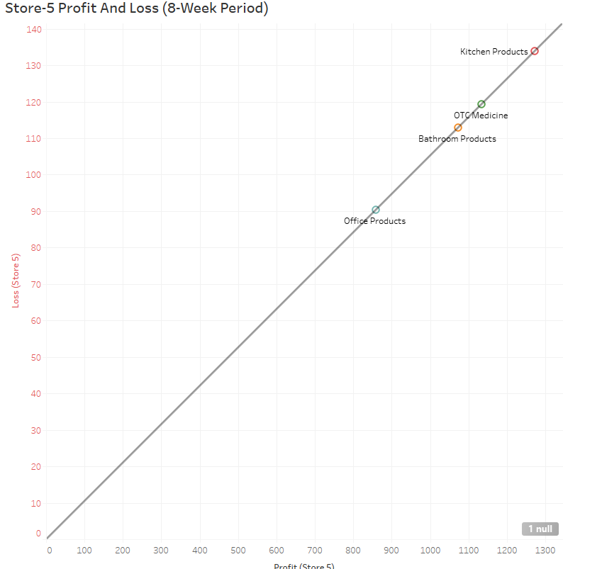

**Store 5 Average Products Sold per Week**

Here are the stores average percentages of sales per week.

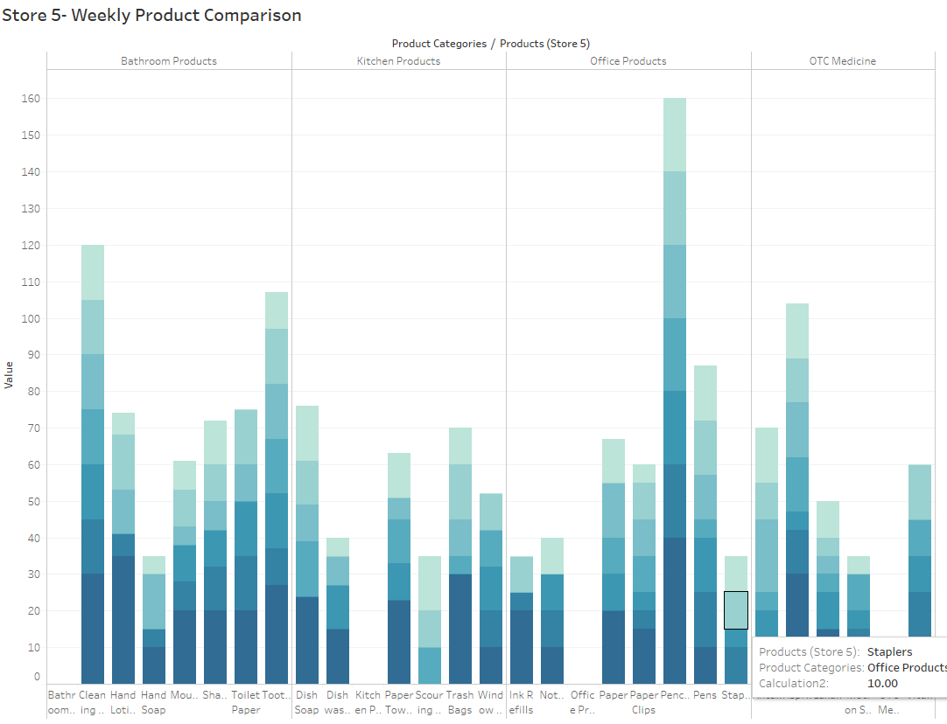

**Store 5 Inventory Turn Over:**

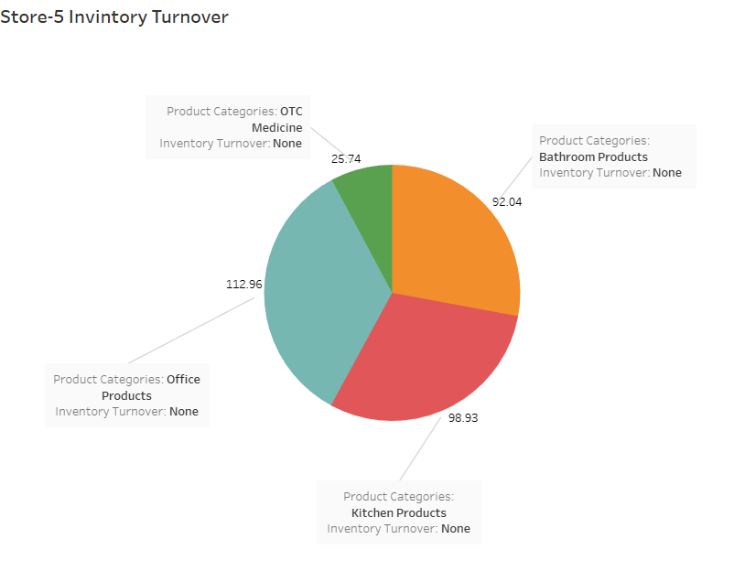

 This is the measure of how often Super Shoppers Store 1 sells through its entire inventory in a set period of 8 weeks. By dividing the total sales by the average inventory value

**Store 5 Sell Through Rate:**

Sell-through rate is a calculation that is used to measure the amount of product received from your manufacturer against the amount of product sold to your customers in a specified period of time.

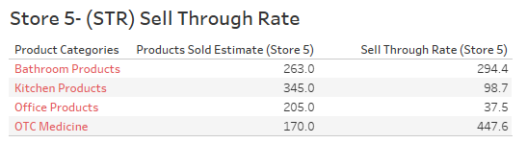

**Store 5 ROI:**

Return on investment based on calculating the profit made divided by the initial cost of products purchased in inventory:

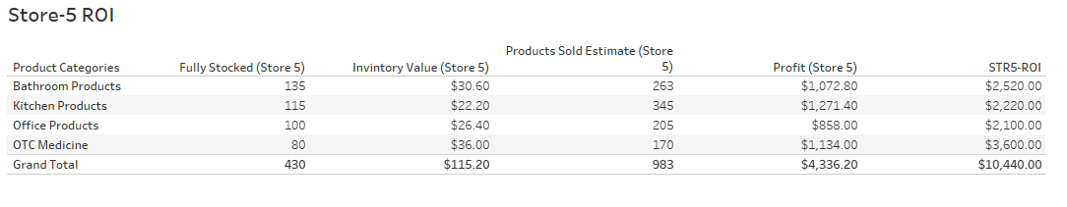

**Store 6 Analysis:**

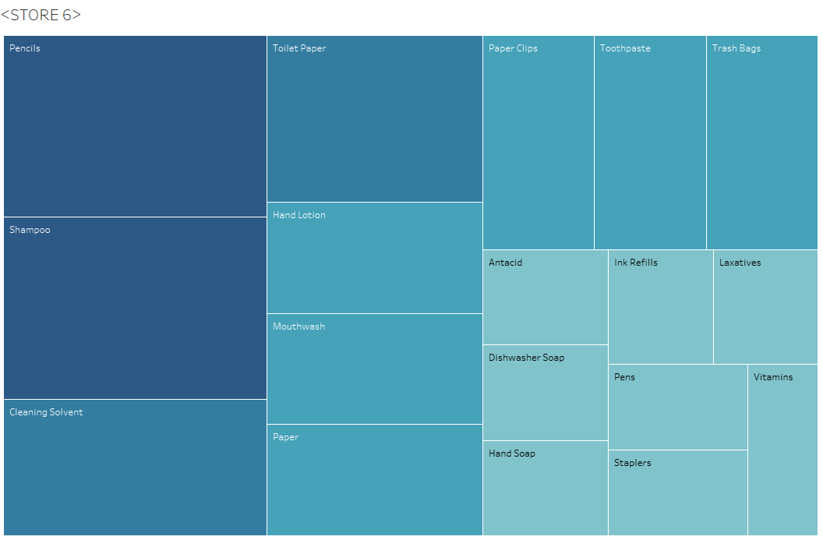

**Store 6 Data Analysis:**

**Errors:**

* In week 6 in **Store 6** the hand soap product value is ether mis entered or wrong inventory control amounts were sent to Store 6. Without the time series data and detail of sold products or customer retention data this is undetermined

**Store 6 Highest selling products:**

Over the past 7 weeks to present these top products sold out the most and where not in stock

|  |  |  |  |  |
| --- | --- | --- | --- | --- |
| **Product** | **Stock Amount** | **#Weeks Sold out** | **Product Avg (Needed Per Week)** | **Analysis** |
| Scouring Pads | 20 | 4 | 4 | Increase Stock Amount and reorder point |
| Ink refills | 10 | 3 | 4 | Increase Stock Amount and reorder point |
| Dishwashing Soap | 15 | 3 | 4 | Increase Stock Amount and reorder point |
| Window Cleaner | 20 | 3 | 5 | Increase Stock Amount and reorder point |
| Shampoo | 20 | 3 | 7 | Increase Stock Amount and reorder point |

I recommend increasing the stock amount to meet the demand especially for All products listed above that go more than 3 weeks without replenishing store 6 inventory. I recommend that the warehouse reorder point be dropped to a less amount to cover the demand of the listed products.

Recommendations **Store 6**:

* Increase sold out product reorder point by 5 units doubling the units being sent to 10 units per week on average.
* Work on new lean Inventory management strategy and 5s

Also, follow recommendations and best practices I have outlined in the recommendations section of the analysis above. The store should implement product placement and staging strategies to facilitate increasing profit margin through demand and visibility. I would also recommend instore management check to see if sound inventory management and tracking processes are being conducted correctly.

**Product Average** = Average of All sales divided by each week minus the full stock amount times 100 percent.

**Store 6 Lowest selling products:**

|  |  |  |  |  |
| --- | --- | --- | --- | --- |
| **Product** | **Stock Amt** | **Sold (8weeks)** | **Product Avg (Needed Per Week)** | **Analysis** |
| Pencils | 20 | 0 | 20 | Remove product from store or reduce stock Amount to 5 or increase resell point by 75% |
| Cleaning Solvent | 15 | 0 | 15 | Reduce Stock Amount to 10 and reorder point by 50% |
| Antacids | 15 | 0 | 9 | Reduce Stock Amount to 10 and reorder point by 50% Increased by 5 units |
| Paper | 20 | 0 | 9 | Reduce Stock Amount to 10 and reorder point by 50% |

**Store 6 Product Profit and Loss:**

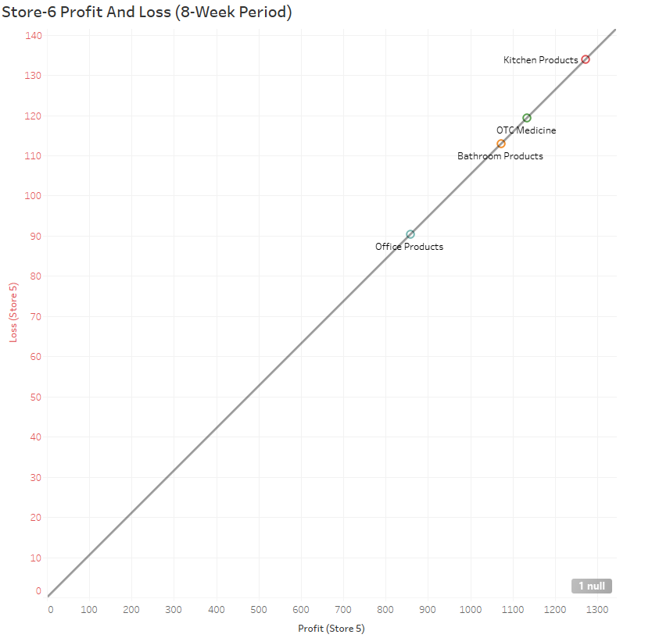

**Store 6 Average Products Sold per Week**

Here are the stores average percentages of sales per week.

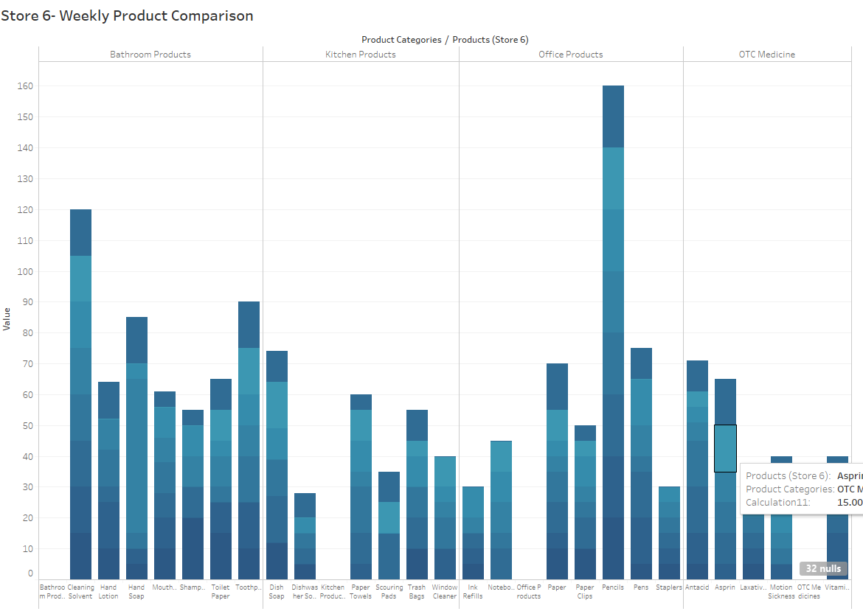

**Store 6 Inventory Turn Over:**

 This is the measure of how often Super Shoppers Store 1 sells through its entire inventory in a set period of 8 weeks. By dividing the total sales by the average inventory value.

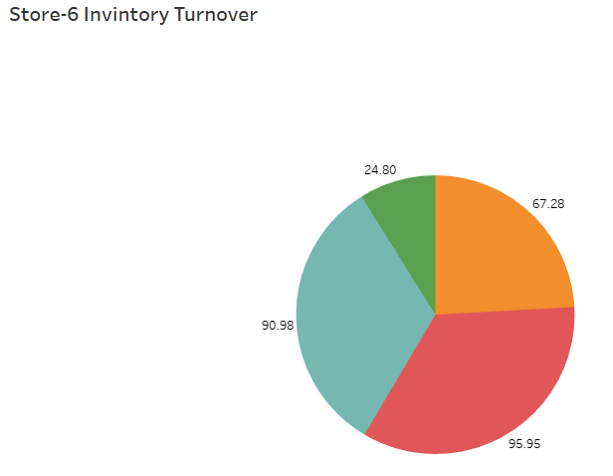

**Store 6 Sell Through Rate:**

Sell-through rate is a calculation that is used to measure the amount of product received from your manufacturer against the amount of product sold to your customers in a specified period of time.

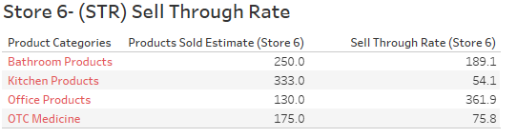

**Store 6 ROI:**

Return on investment based on calculating the profit made divided by the initial cost of products purchased in inventory on calculating the profit made divided by the initial cost of products purchased in inventory.

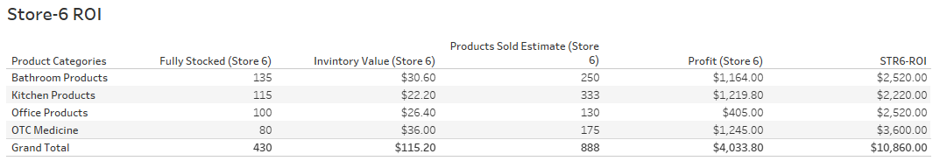

**Store 7 Analysis:**

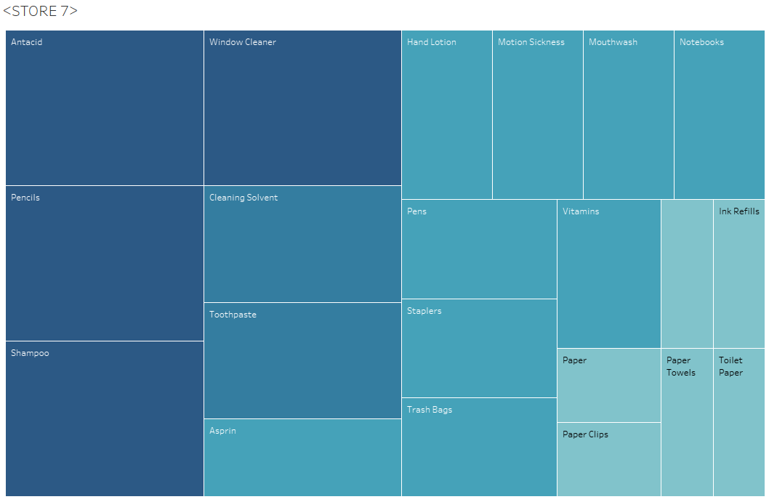

**Store 7 Data Analysis:**

**Errors:**

* From Week 3 to week 6 in Store 7 products sell out occurs because reorder point is to high and reorder amount to replenish products is too low.

**Store 7 Highest selling products:**

Over the past 7 weeks to present these top products sold out the most and where not in stock

|  |  |  |  |  |
| --- | --- | --- | --- | --- |
| **Product** | **Stock Amount** | **#Weeks Sold out** | **Product Avg (Needed Per Week)** | **Analysis** |
| Scouring Pads | 20 | 4 | 4 |  |
| Dish Soap | 20 | 3 | 5 | Increase Stock Amount by 10 and reorder point add 5 units |
| Hand Soap | 20 | 3 | 4 | Increase Stock Amount by 10 and reorder point add 5 units |
| Dishwashing Soap | 15 | 3 | 5 | Increase Stock Amount by 10 and reorder point add 5 units |
| Toothpaste | 15 | 3 | 5 | Increase Stock Amount by 10 and reorder point add 5 units |
| Paper Clips | 10 | 3 | 8 | Increase Stock Amount by 10 and reorder point add 5 units |
| Laxatives | 10 | 3 | 5 | Increase Stock Amount by 10 and reorder point add 5 units |

I recommend increasing the stock amount to meet the demand especially for All products listed above that go more than 3 weeks without replenishing store 5 inventory. I recommend that the warehouse reorder point be dropped to a less amount to cover the demand of the listed products.

Recommendations **Store 7**:

* Increase sold out product reorder point by 5 units doubling the units being sent to 10 units per week on average.

Also, follow recommendations and best practices I have outlined in the recommendations section of the analysis above.

**Product Average** = Average of All sales divided by each week minus the full stock amount times 100 percent.

**Store 7 Lowest selling products:**

|  |  |  |  |  |
| --- | --- | --- | --- | --- |
| **Product** | **Stock Amt** | **Sold (8weeks)** | **Product Avg (Needed Per Week)** | **Analysis** |
| Pencils | 20 | 0 | 20 | Remove product from store or reduce stock Amount to 5 or increase resell point by 75% |
| Cleaning Solvent | 15 | 0 | 15 | Reduce Stock Amount to 10 and reorder point by 50% |

**Store 7 Product Profit and Loss:**

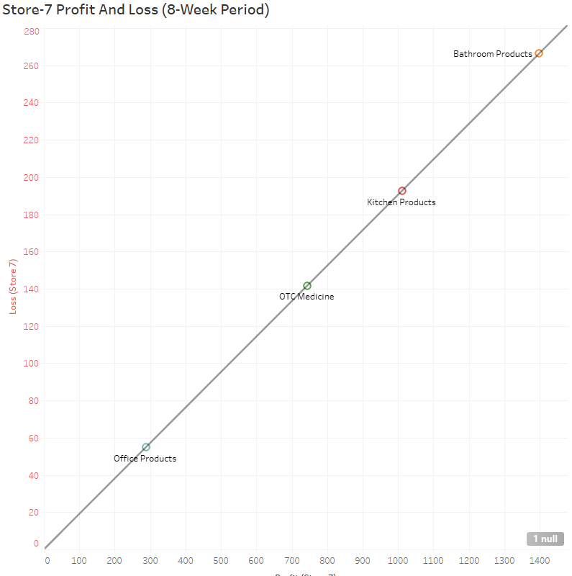

**Store 7 Average Products Sold per Week**

Here are the store average product percentages of sales per week.

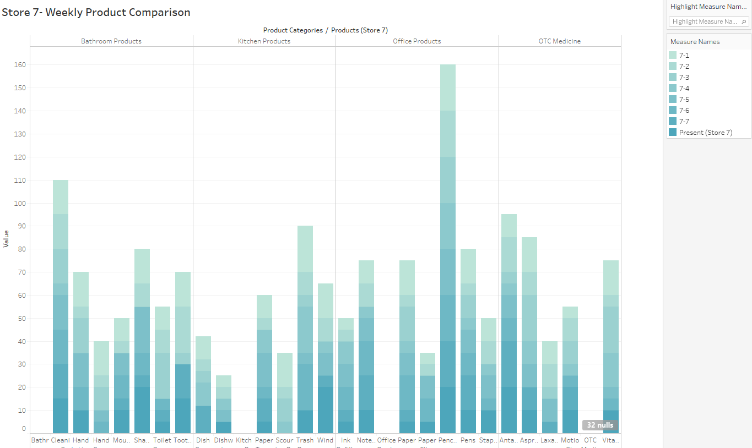

**Store 7 Inventory Turn Over:**

 This is the measure of how often Super Shoppers Store 1 sells through its entire inventory in a set period of 8 weeks. By dividing the total sales by the average inventory value.

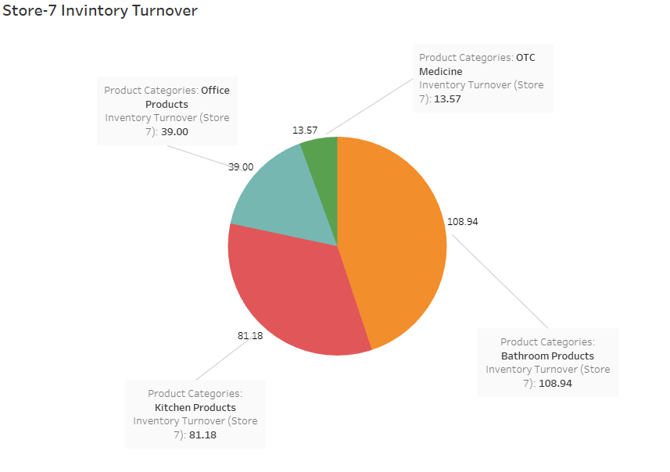

**Store 7 Sell Through Rate:**

Sell-through rate is a calculation that is used to measure the amount of product received from your manufacturer against the amount of product sold to your customers in a specified period of time.

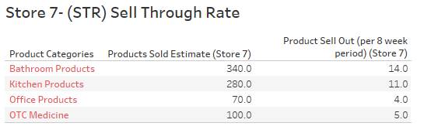

**Store 7 ROI:**

Return on investment based on calculating the profit made divided by the initial cost of products purchased in inventory.

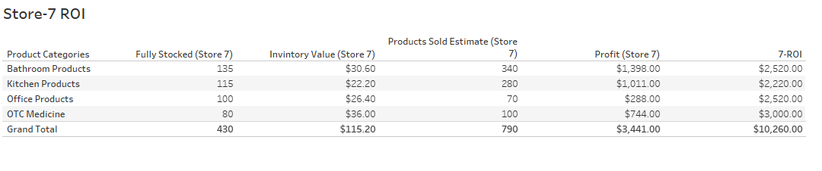

**Store 8 Analysis:**

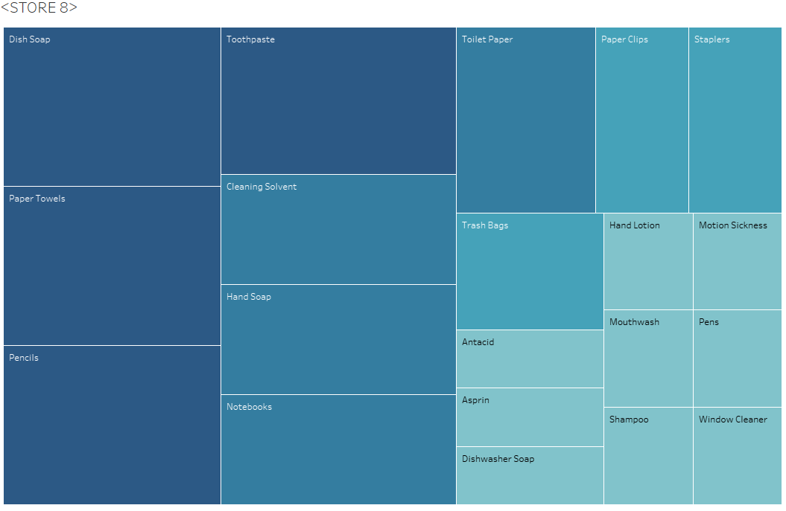

**Store 8 Data Analysis:**

**Errors:**

* In week 3 in **Store 8** products seem to being doing well until this point. After week 3 multiple incursions of no inventory has been delivered for the items listed below
* Patter with scouring pads and Ink refills is persisting. This suggest that there is a point of sale error, warehouse reorder error, or inventory management error.

**Store 8 Highest selling products:**

Over the past 8 weeks to present these top products sold out the most and where not in stock

|  |  |  |  |  |
| --- | --- | --- | --- | --- |
| **Product** | **Stock Amount** | **#Weeks Sold out** | **Product Avg (Needed Per Week)** | **Analysis** |
| Scouring Pads | 20 | 5 | 4 | Increase Stock Amount by 10 and reorder point add 5 units. |
| Ink refills | 10 | 4 | 6 | Increase Stock Amount by 10 and reorder point add 5 units. |
| Shampoo | 20 | 4 | 4 | Increase Stock Amount by 10 and reorder point add 5 units. |
| Laxatives | 10 | 3 | 5 | Increase Stock Amount by 10 and reorder point add 5 units. |

I recommend increasing the stock amount to meet the demand especially for All products listed above that go more than 3-4 weeks without replenishing store 8 inventory. I recommend that the warehouse reorder point be dropped to a less amount to cover the demand of the listed products. Also, follow recommendations and best practices I have outlined in the recommendations section of the analysis.

**Product Average** = Average of All sales divided by each week minus the full stock amount times 100 percent.

**Store 8 Lowest selling products:**

|  |  |  |  |  |
| --- | --- | --- | --- | --- |
| **Product** | **Stock Amt** | **Sold (8weeks)** | **Product Avg (Needed Per Week)** | **Analysis** |
| Pencils | 20 | 0 | 20 | Remove product from store or reduce stock Amount to 5 or increase resell point by 75% |
| Cleaning Solvent | 15 | 0 | 15 | Reduce Stock Amount to 10 and reorder point by 50% |

**Store 8 Product Profit and Loss:**

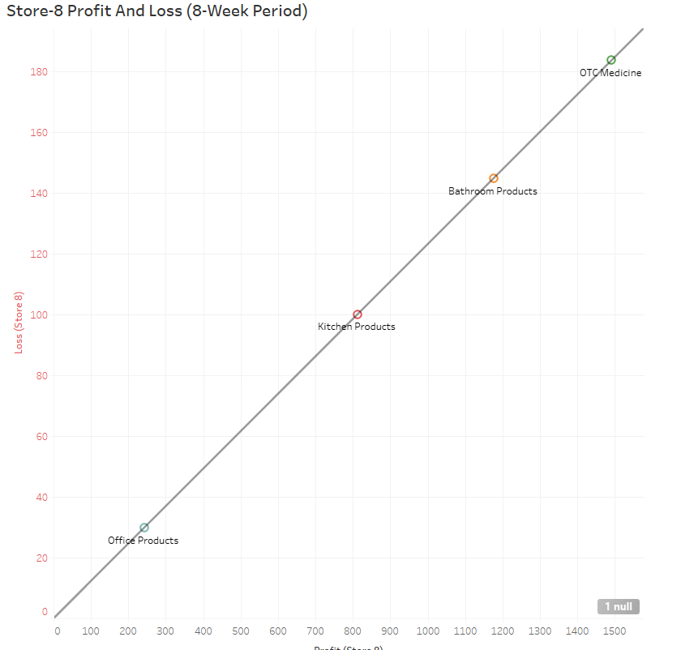

**Store 8 Average Products Sold per Week**

Here are the stores average percentages of sales per week.

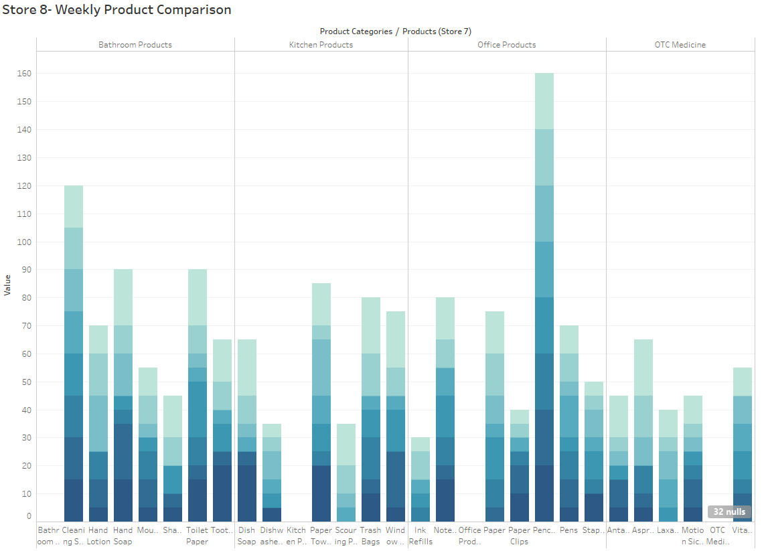

**Store 8 Inventory Turn Over:**

 This is the measure of how often Super Shoppers Store 1 sells through its entire inventory in a set period of 8 weeks. By dividing the total sales by the average inventory value.

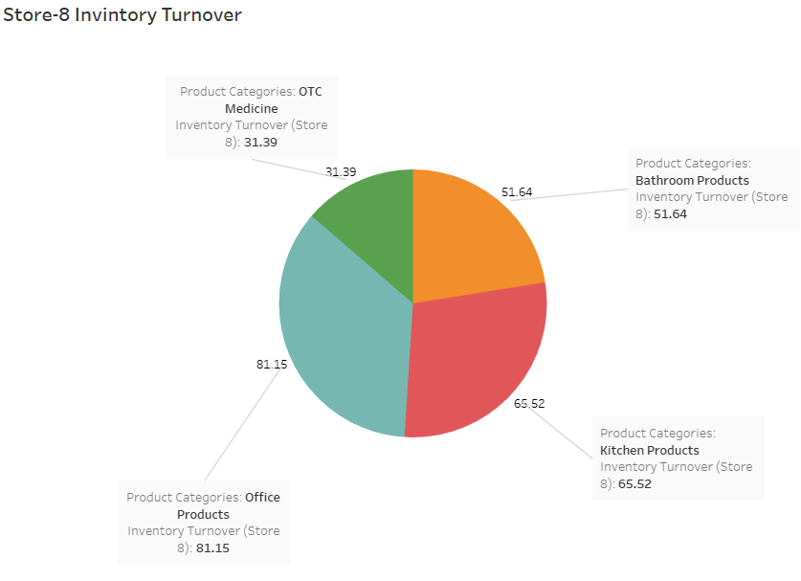

**Store 8 Sell Through Rate:**

Sell-through rate is a calculation that is used to measure the amount of product received from your manufacturer against the amount of product sold to your customers in a specified period of time.

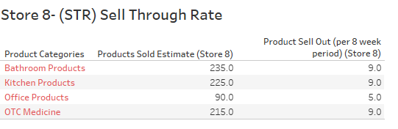

**Store 8 ROI:**

Return on investment based on calculating the profit made divided by the initial cost of products purchased in inventory.

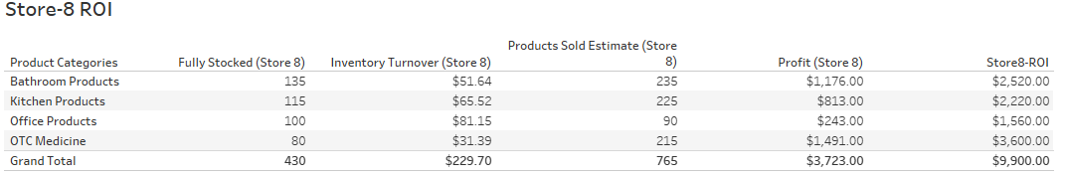

**Store 9 Analysis:**

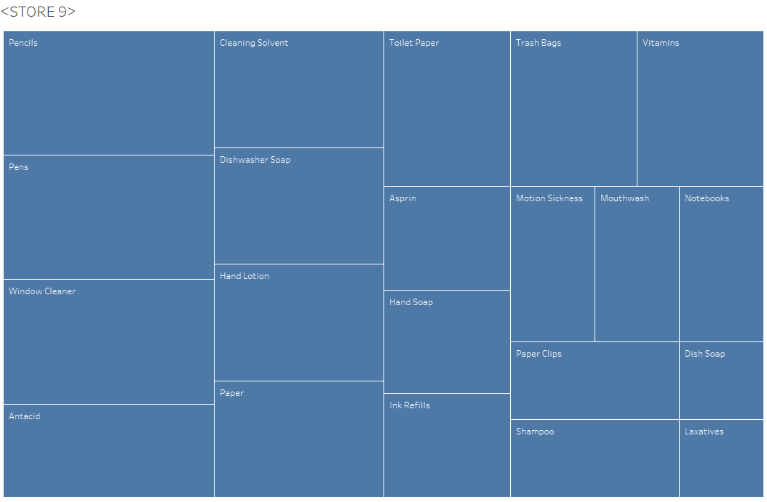

**Store 9 Data Analysis:**

**Errors:**

* Scouring Pads being out of stock for more than 4 weeks
* Pencils and Cleaning solvent not sold in 8-weeks

**Store 9 Highest Selling products:**

Over the past 7 weeks to present these top products sold out the most and where not in stock

|  |  |  |  |  |
| --- | --- | --- | --- | --- |
| **Product** | **Stock Amount** | **#Weeks Sold out** | **Product Avg (Needed Per Week)** | **Analysis** |
| Scouring Pads | 20 | 5 | 4 | Increase Stock Amount by 10 and reorder point add 5 units. |
| Ink refills | 10 | 4 | 4 | Increase Stock Amount by 10 and reorder point add 5 units. |
| Hand Soap | 20 | 4 | 4 | Increase Stock Amount by 10 and reorder point add 5 units. |
| Aspirin | 20 | 3 | 7 | Increase Stock Amount by 10 and reorder point add 5 units. |
| Dishwashing Soap | 15 | 4 | 5 | Increase Stock Amount by 10 and reorder point add 5 units. |
| Motion Sickness | 10 | 3 | 4 | Increase Stock Amount by 10 and reorder point add 5 units. |

I recommend increasing the stock amount to meet the demand especially for All products listed above that go more than 3 weeks without replenishing store 9 inventory. I recommend that the warehouse reorder point be dropped to a less amount to cover the demand of the listed products.

Recommendations **Store 9**:

* Implement proper training and inventory management collaboration with warehouse

Also, follow recommendations and best practices I have outlined in the recommendations section of the analysis above.

**Product Average** = Average of All sales divided by each week minus the full stock amount times 100 percent.

**Store 9 Lowest selling products:**

|  |  |  |  |  |
| --- | --- | --- | --- | --- |
| **Product** | **Stock Amt** | **Sold (8weeks)** | **Product Avg (Needed Per Week)** | **Analysis** |
| Pencils | 20 | 0 | 20 | Remove product from store or reduce stock Amount to 5 or increase resell point by 75% |
| Cleaning Solvent | 15 | 0 | 15 | Reduce Stock Amount to 10 and reorder point by 50% |

**Store 9 Product Profit and Loss:**

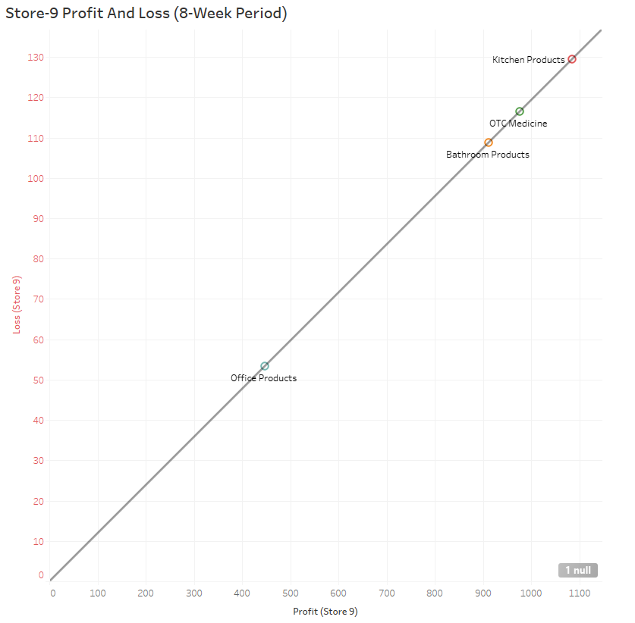

**Store 9 Average Products Sold per Week**

Here are the stores average percentages of sales per week

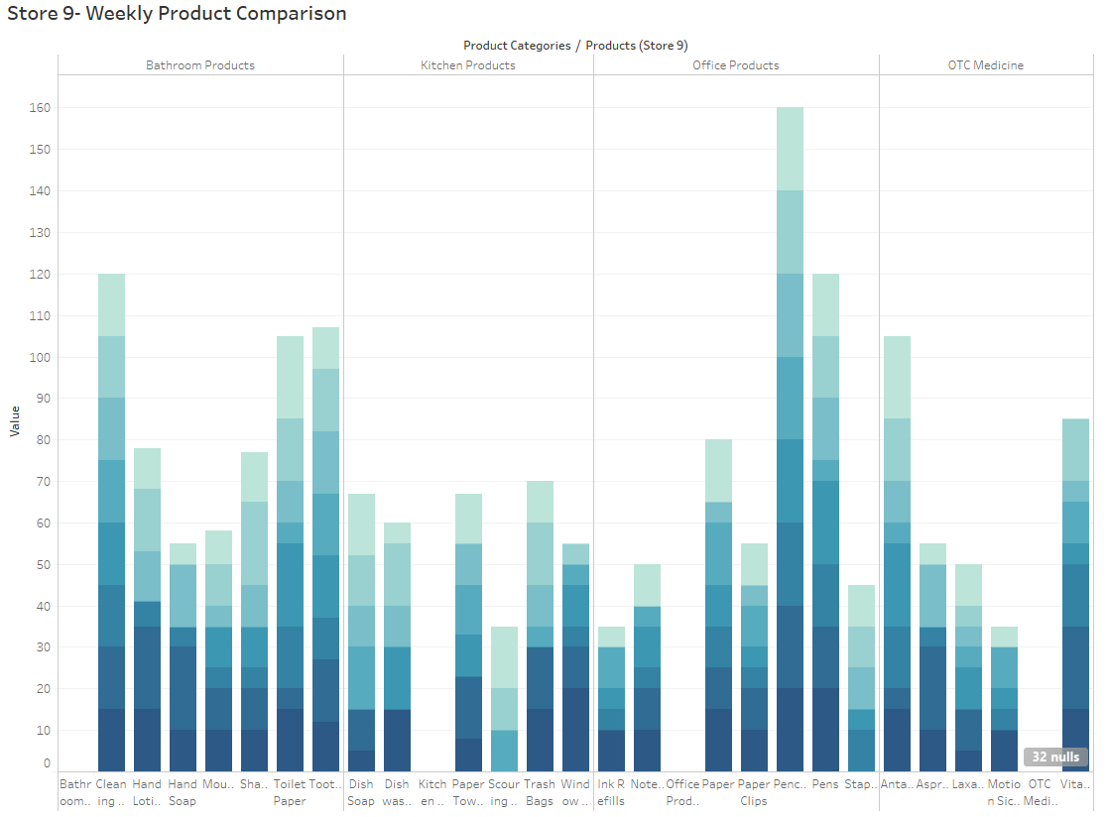

**Store 9 Inventory Turn Over:**

 This is the measure of how often Super Shoppers Store 1 sells through its entire inventory in a set period of 8 weeks. By dividing the total sales by the average inventory value.

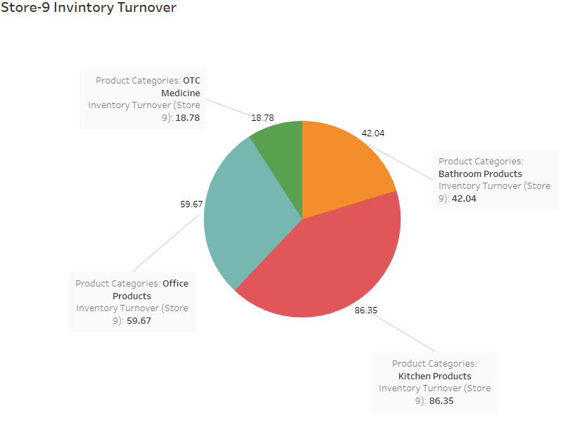

**Store 9 Sell Through Rate:**

Sell-through rate is a calculation that is used to measure the amount of product received from your manufacturer against the amount of product sold to your customers in a specified period of time.

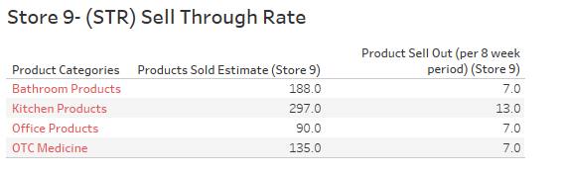

**Store 9 ROI:**

Return on investment based on calculating the profit made divided by the initial cost of products purchased in inventory.

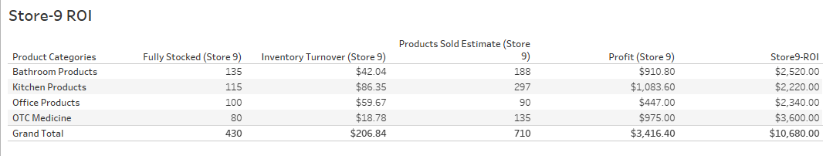

**Store 10 Analysis:**

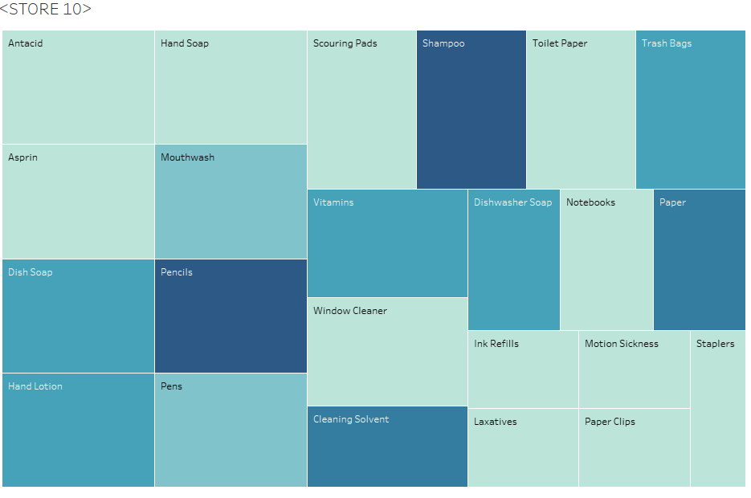

**Store 10 Data Analysis:**

**Errors:**

* By far the worst store of them all as far as Inventory management and reorder points are concerned. Over 11 products that go unstocked/ out of stock for 3 to 5 weeks.

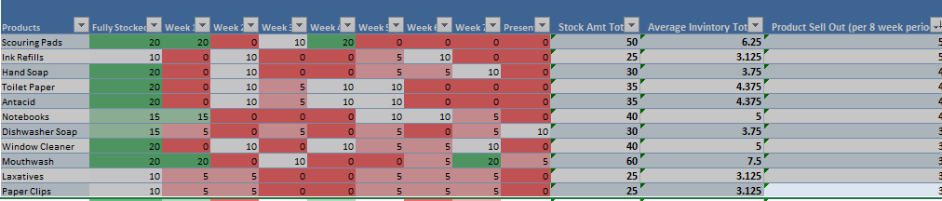

**Store 10 Highest selling products:**

Over the past 7 weeks to present these top products sold out the most and where not in stock

|  |  |  |  |  |
| --- | --- | --- | --- | --- |
| **Product** | **Stock Amount** | **#Weeks Sold out** | **Product Avg (Needed Per Week)** | **Analysis** |
| Scouring Pads | 20 | 5 | 6 | Increase Stock Amount by 10 and reorder point add 5 units. |
| Ink refills | 10 | 5 | 3 | Increase Stock Amount by 10 and reorder point add 5 units. |
| Hand Soap | 20 | 4 | 4 | Increase Stock Amount by 10 and reorder point add 5 units. |
| Toilet Paper | 10 | 4 | 4 | Increase Stock Amount by 10 and reorder point add 5 units. |
| Antacids |  | 4 | 4 | Increase Stock Amount by 10 and reorder point add 5 units. |
| Notebooks | 15 | 4 | 5 | Increase Stock Amount by 10 and reorder point add 5 units. |
| Dishwashing Soap | 15 | 4 | 3 | Increase Stock Amount by 10 and reorder point add 5 units. |
| Window Cleaner |  | 3 | 5 | Increase Stock Amount by 10 and reorder point add 5 units. |
| Mouthwash |  | 3 | 7 | Increase Stock Amount by 10 and reorder point add 5 units. |
| Laxatives | 10 | 3 | 3 | Increase Stock Amount by 10 and reorder point add 5 units. |
| Paperclips |  | 3 | 3 | Increase Stock Amount by 10 and reorder point add 5 units. |

I recommend increasing the stock amount to meet the demand especially for All products listed above that go more than 3 weeks without replenishing store 5 inventory. I recommend that the warehouse reorder point be dropped to a less amount to cover the demand of the listed products.

Recommendations **Store 10**:

* Increase sold out product reorder point by 5 units doubling the units being sent to 10 units per week on average.
* Employee training
* Implement new SAM Lean management system for inventory
* Implement and train warehouse and store 10 on implementing the 5 S’s
* Implement sound inventory management scheduling

Also, follow recommendations and best practices I have outlined in the recommendations section of the analysis above. The store should implement product placement and staging strategies to facilitate increasing profit margin through demand and visibility. I would also recommend instore management check to see if sound inventory management and tracking processes are being conducted correctly.

**Product Average** = Average of All sales divided by each week minus the full stock amount times 100 percent.

**Store 10 Lowest selling products:**

|  |  |  |  |  |
| --- | --- | --- | --- | --- |
| **Product** | **Stock Amt** | **Sold (8weeks)** | **Product Avg (Needed Per Week)** | **Analysis** |
| Pencils | 20 | 0 | 20 | Remove product from store or reduce stock Amount to 5 or increase resell point by 75% |
| Cleaning Solvent | 15 | 0 | 15 | Reduce Stock Amount to 10 and reorder point by 50% |

**Store 10 Product Profit and Loss:**

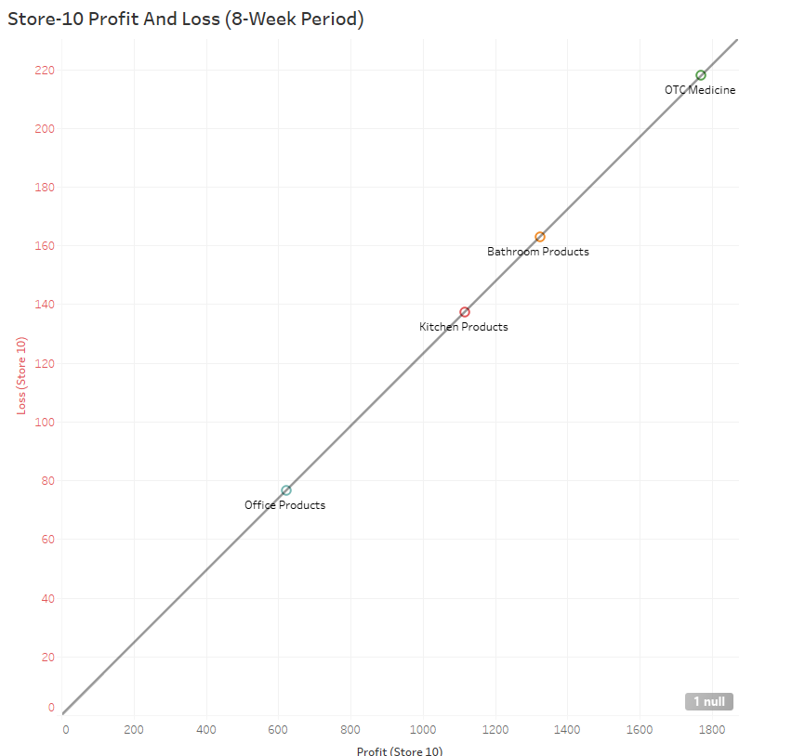

**Store 10 Average Products Sold per Week**

Here are the stores average percentages of sales per week.

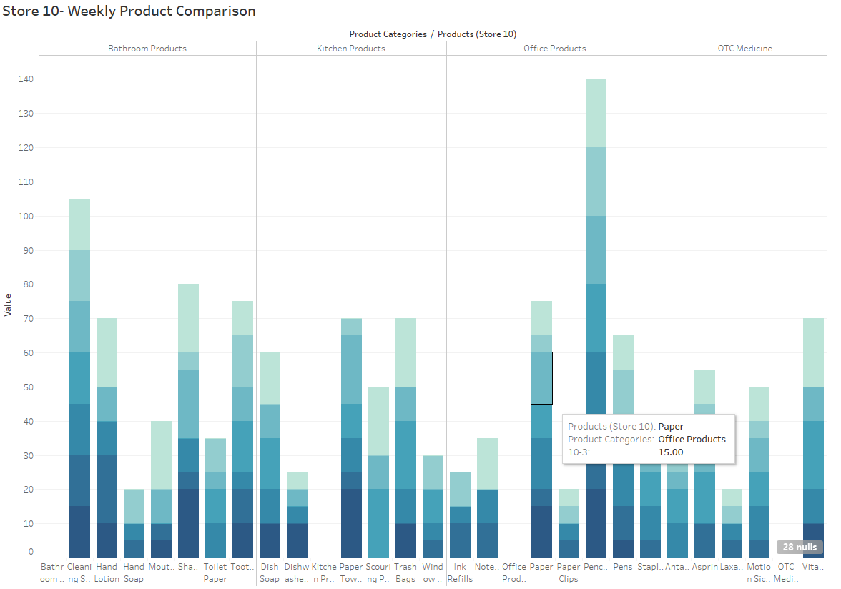

**Store 10 Inventory Turn Over:**

 This is the measure of how often Super Shoppers Store 1 sells through its entire inventory in a set period of 8 weeks. By dividing the total sales by the average inventory value.

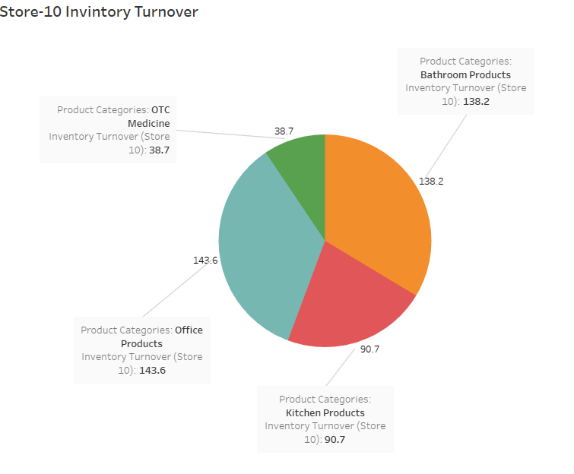

**Store 10 Sell Through Rate:**

Sell-through rate is a calculation that is used to measure the amount of product received from your manufacturer against the amount of product sold to your customers in a specified period of time.

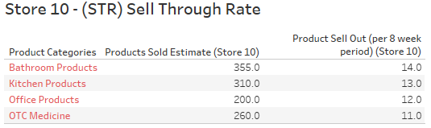

**Store 10 ROI:**

Return on investment based on calculating the profit made divided by the initial cost of products purchased in inventory.

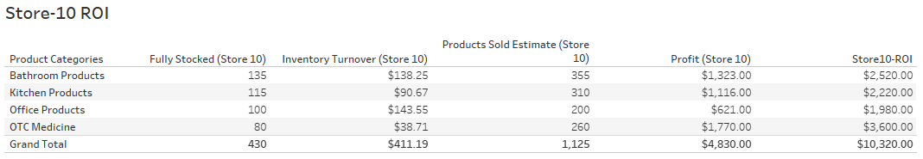

This concludes my in-depth analysis of each of the 10-Super Shopper Store locations. Please see the recommendations and the analysis at the beginning of the document. My next report be a full Analysis and presentation incorporating the data and overall factors and recommendations. Also, it will contain the inclusive metrics and combinatorics data analysis such as ( regression analysis, ROI, Inventory, Turn Over, Sell Through, Averages Inventory sales) Overall factors for the entire Super Shopper Company.

# References

5S Today. (2020). *What is 5S?* Retrieved from https://www.5stoday.com: https://www.5stoday.com/what-is-5s/

DEAR Systems. (2017, Aug 05). *What is a Reorder Point Formula and How is it Calculated?* Retrieved from https://dearsystems.com: https://dearsystems.com/reorder-point-formula/

Fdm4. (2020, Nov 25). *HOW TO ORGANIZE WAREHOUSE INVENTORY*. Retrieved from www.fdm4.com: https://www.fdm4.com/how-to-organize-warehouse-inventory/

Gartner Peer Insights. (2020). *Software Asset Management (SAM) Tools Reviews and Ratings*. Retrieved from https://www.gartner.com: https://www.gartner.com/reviews/market/software-asset-management-tools

Systems, D. (2017, Nov 17). *10 Inventory Management Best Practices for Improving Your Business*. Retrieved from https://dearsystems.com: https://dearsystems.com/inventory-management-best-practices/